**PRACTICAL-10**

JK Enterprises wants to create a service in IBM Security Identity Manager to manage accounts and groups on Linux systems. Organization wants a password policy that will take password for the Linux Service to be at least four characters long. Password policy should be checked for employee Alice Smyth.

**Linux service**

The Portable Operating System Interface (POSIX) is a family of standards specified by the IEEE Computer Society for maintaining compatibility between operating systems. POSIX defines the application programming interface (API), along with command line shells and utility interfaces, for software compatibility with variants of Linux and other operating systems.

TASKS:

1. Creating a Linux Service.
2. Creating a password policy.
3. Running reconciliation on Linux.
   1. Running an initial reconciliation.
   2. Review Account list.
4. Verifying the password policy.

Implementation:

1. Creating a Linux Service.
   1. Log in to the IBM Security Identity Manager Administrative Console as the system administrator with the user ID (itim manager).

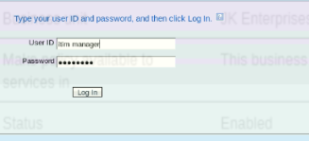

* 1. On the Home tab, navigate to Manage Services.Click Create.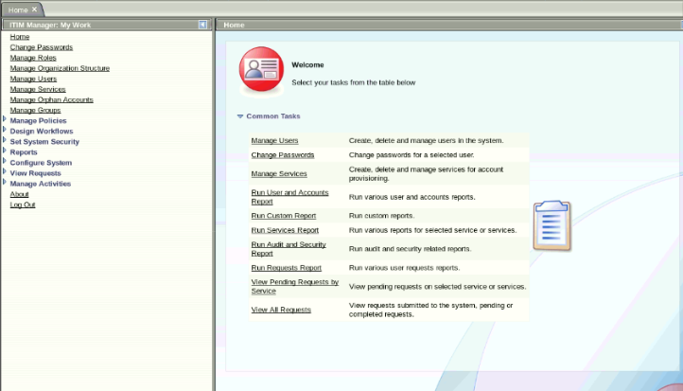
  2. Wait for the list of services to appear.Ensure that Business unit is set to JKE2 Enterprises.Select POSIX Linux profile and click Next.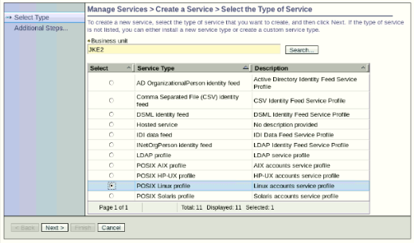
  3. Fill the following details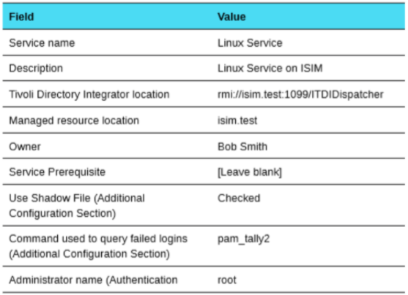

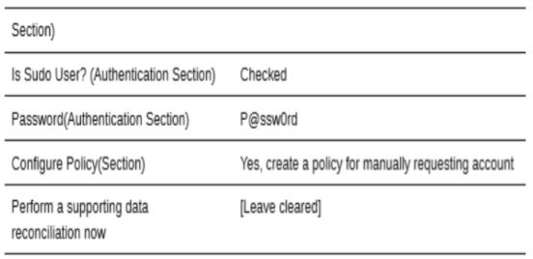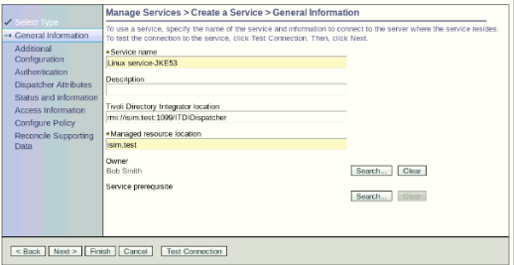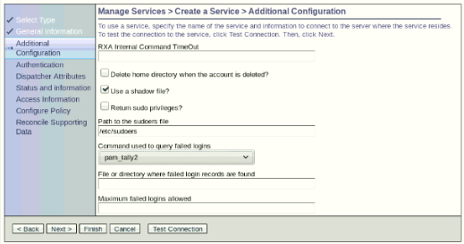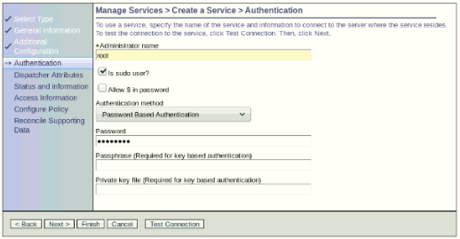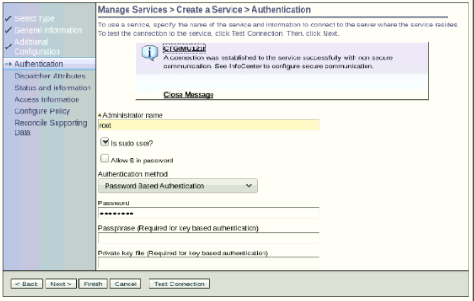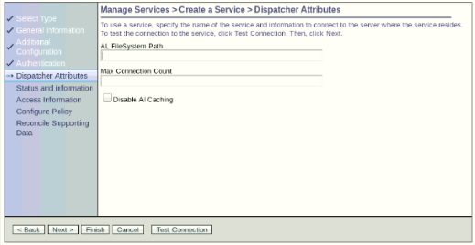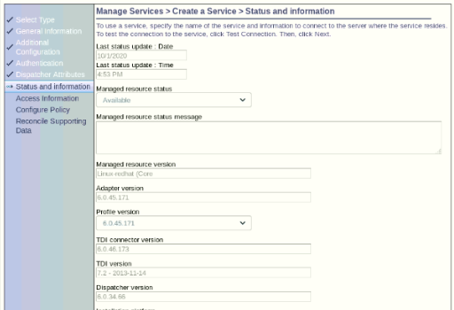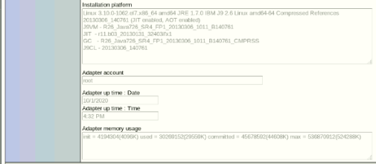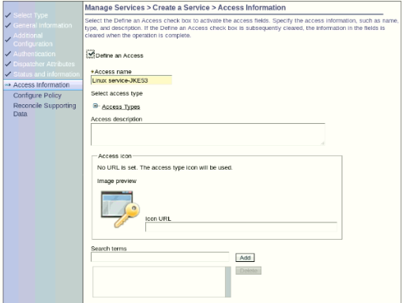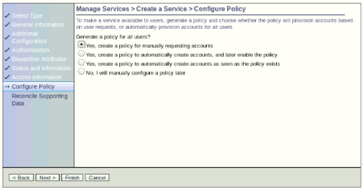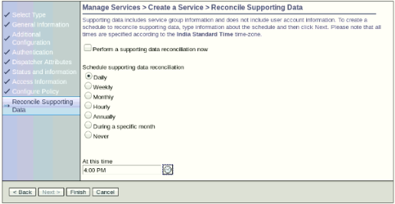

* 1. Click Finish to create the service.Verify that the Linux Service was added. 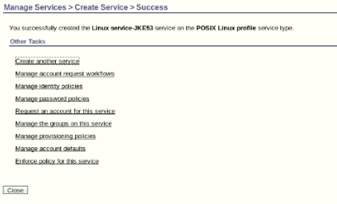



1. Creating a password policy.
   1. On the Home tab, navigate to Manage Policies > Manage Password Policies.

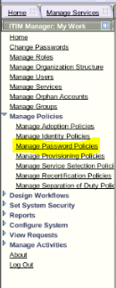

* 1. Fill the following details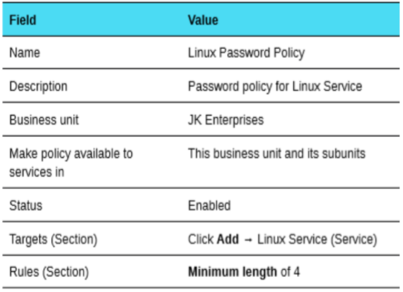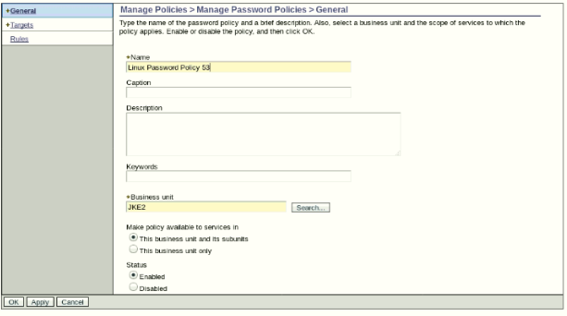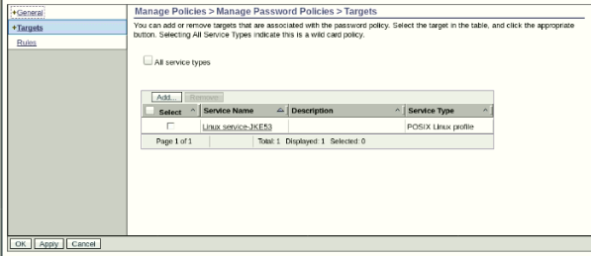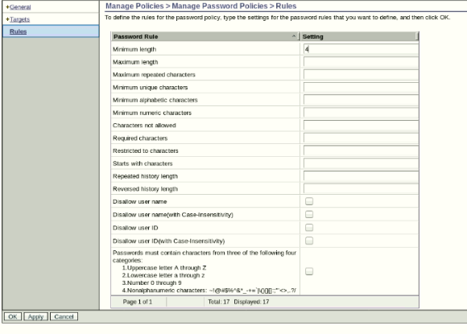
  2. Click OK to submit the new password policy.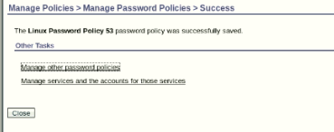

1. Running reconciliation on Linux.
   1. Running an initial reconciliation.
      1. Go to Manage Services.

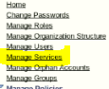

* + 1. Click the small arrow to the right of Linux Service and click Reconcile Now.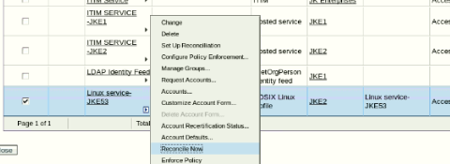
    2. Select None for Query when prompted, and submit the request.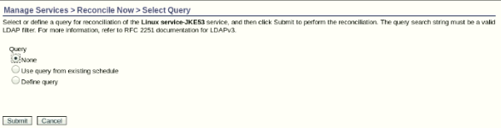
    3. View the status of the reconciliation request.Refresh the list after a few moments if the status is pending.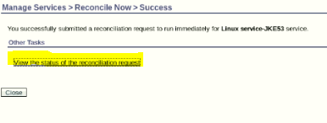
    4. Close Reconcile Now Tab.
  1. Review Account list.
     1. Go to Manage Services



* + 1. Click the small arrow to the right of Linux Service and click Accounts.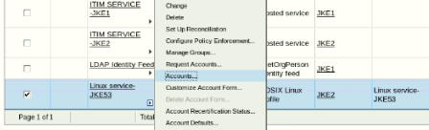
    2. Click Search to display all the accounts that are found by the reconciliation.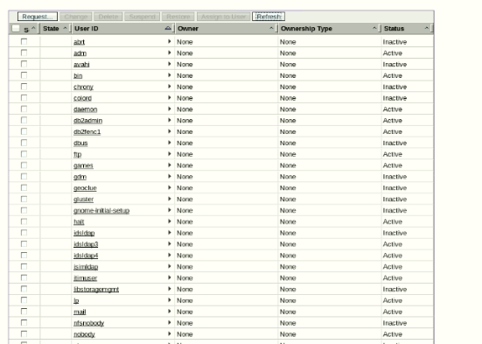
    3. Close the Manage Accounts tab.

1. Verifying the password policy.
   1. On the Home tab, go to Manage Services.



* 1. Click the small arrow to the right of Linux Service and click Request Accounts.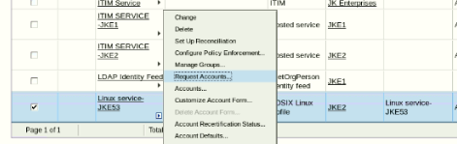
  2. Click Search to show all users.Select Alice Smyth and click Continue. Click Submit now.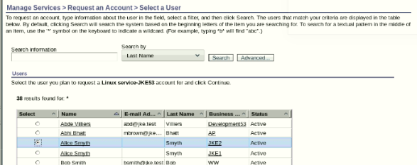
  3. On the Home tab, go to Manage Users.

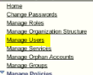

* 1. Click Refresh to show all users.Click the small arrow to the right of the Alice Smyth entry and click Change Passwords.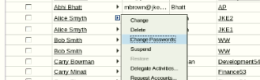
  2. Enter a password of aa and try to submit the change. This action should violate password policy on Linux Service because the password is too short.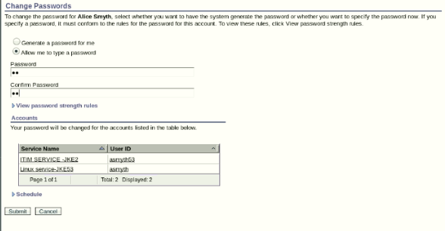
  3. Read the error message on the screen.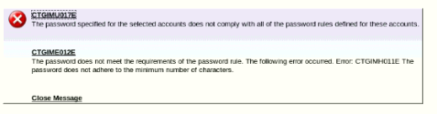
  4. Click the small triangle to the left of View password strength rules to confirm that the minimum length for a password is four characters. Click Cancel.